Path To Agility®
Achieving Your Goals Is A Journey
Why Path to Agility?
The journey toward Agility can be long and challenging. Our experience and research has shown that the vast majority of organizations who take on an Agile transformation will either experience “superficial agility” which usually results in failure and reverting back to old, ineffective behaviors, or “pocket agility”, where some things may improve, but falls short of the true organizational improvements needed to be more resilient.
This is why we created the Path to Agility. It is a proven Agile transformation framework designed to help guide organizations through their Agile transformation journey. It helps organizations achieve specific business outcomes by providing a clear approach for identifying the capabilities needed for navigating change and the visibility needed to resolve obstacles and adapt along the path.
The Path to Agility (P2A) is designed with the following objectives in mind:
- To provide visibility into transformation outcomes, progress, and impediments.
- To enable the communication of the past, present, and future value within a context the everyone in the organization can understand.
- To provide change agents and leaders with proven patterns to improve transformation consistency, quality, and results.
- To enable transfer of ownership to key decision-makers, practitioners, and stakeholders at all levels of the organization.
Path to Agility Framework

Stages
The Path to Agility framework consists of 5 stages: Align, Learn, Predict, Accelerate, and Adapt. Each stage provides a point of reference and context for change.
Align: It starts with a compelling purpose, the “why”, for taking on a transformation effort. It’s about addressing the conditions that are challenging the organization and setting a vision and prioritizing key business outcomes accordingly. Lack of alignment creates incoherence and waste that can derail a transformation. Learn: The emphasis is on learning new concepts, terminologies, new ways of thinking and working, and creating a culture of learning.
Predict: This stage is characterized by seeing real, tangible results and the indicators of what’s working in a given context or situation. It’s about getting the volatility out of the systems in order to be more consistent and predictable.
Accelerate: This is about optimizing the full value stream. Tuning the engine that drives shorter cycle times for value delivery.
Adapt: Here organizations have a whole organizational view of agility, based on lean and agile principles, making it more resilient to future market demands.
Align
Learn
Adapt
Predict
Accelerate
Status Quo
Chaos & Resistance
Integration & Practice
The whole
organization has
embraced agility in
order to respond
quickly to market
demands.
The full value stream
is optimized to
shorten time-to-
market.
Teams are able
to maintain
a predictable
candence of delivery
enabling the
business to make
informed business
decisions.
Foundational
Agile practices
are implemented,
teams are taking
ownership of value
delivery, and a
learning culture is
established.
The Agile initiative
is aligned with
measurable
business outcomes
and a clear
transformation
roadmap is defined.

New Status Quo
VERSION 2
With each stage of change, there are core capabilities that enable the continued progress toward the outcomes that the organization is striving for.

Levels
The reality of organizational change is that it’s hard. It takes time and it will be met with resistance. It takes more than just a few people to create a movement that sticks. That’s why the Path to Agility develops the necessary capabilities to deliver outcomes across 3 levels:
Organization level - Leadership develops a modern mindset, increases visibility throughout the organization, and creates alignment around vision, goals and measured success for sustainable organizational change.
System level - Networks of teams are coordinating and collaborating to address dependencies and achieve optimal flow in value delivery.
Team level - Teams successfully take on new roles, establish agile team practices, increase engagement, and achieve sustainable, predictable cadence of delivering value.
Each level defined in the framework has custom outcomes mapped within them that provide visibility into the relationships, dependencies and impacts across all stages of the journey.
An Outcomes-Driven Approach To Business Agility

Outcomes
Path to Agility’s outcomes-based lens helps organizations evaluate where they are on the road to business agility and map out what they should focus on next--no matter where they are in their journey.
Being outcome-focused, rather than practice-driven, means the P2A framework is not intending to prescribe how to implement agile. The emphasis is on building agility, not “doing” Agile. The objective is to help the organization achieve what is needed in order to thrive. The P2A Framework has natural dependencies between outcomes and the outcomes build upon and strengthen each other.

9 Business Outcomes
Before an organization embarks on the road to agility, the leadership team uses the Path to Agility framework to identify and prioritize business outcomes that are best suited to their organization’s needs and goals. The framework provides nine common business outcomes, based on many years of experience, that provide a starting point for alignment:
Continuous Improvement |  | Speed |  | Predictability
The ability of the organization to relentlessly pursue optimizations in all aspects of business functions. |  | The time it takes to deliver an idea into the market. |  | Teams maintain a predictable cadence of delivery enabling the business to make informed business decisions.
Innovation |  | Customer Satisfaction |  | Employee Engagement
New ideas, creative thoughts, or novel imaginations provide better solutions to meet new requirements, unarticulated needs, or known market needs. |  | Customers are satisfied with the experience, benefits, and outcomes when using your product or service. |  | Employees are more satisfied in their work, willing to go the extra mile, passionate about the purpose of their jobs, and committed to the organization.
Productivity |  | Market Responsiveness |  | Quality
Increase the business value realized while maintaining or reducing costs. |  | The ability of the organization to pivot quickly to respond to ever-changing market demands. |  | The product or services meets the expectations of the market for usability, reliability, etc.
Path to Agility® 2.2.2 Business Outcomes Card Set
Organizations can customize Path to Agility to their preferred Business Outcomes, using the related set of Agile
Outcomes and Agile Capabilities as a comprehensive roadmap to help visualize and build on the necessary Agile Practices that enable and drive tangible results. Every aspect in the Agile transformation journey can be clearly mapped to help align and measure progress.
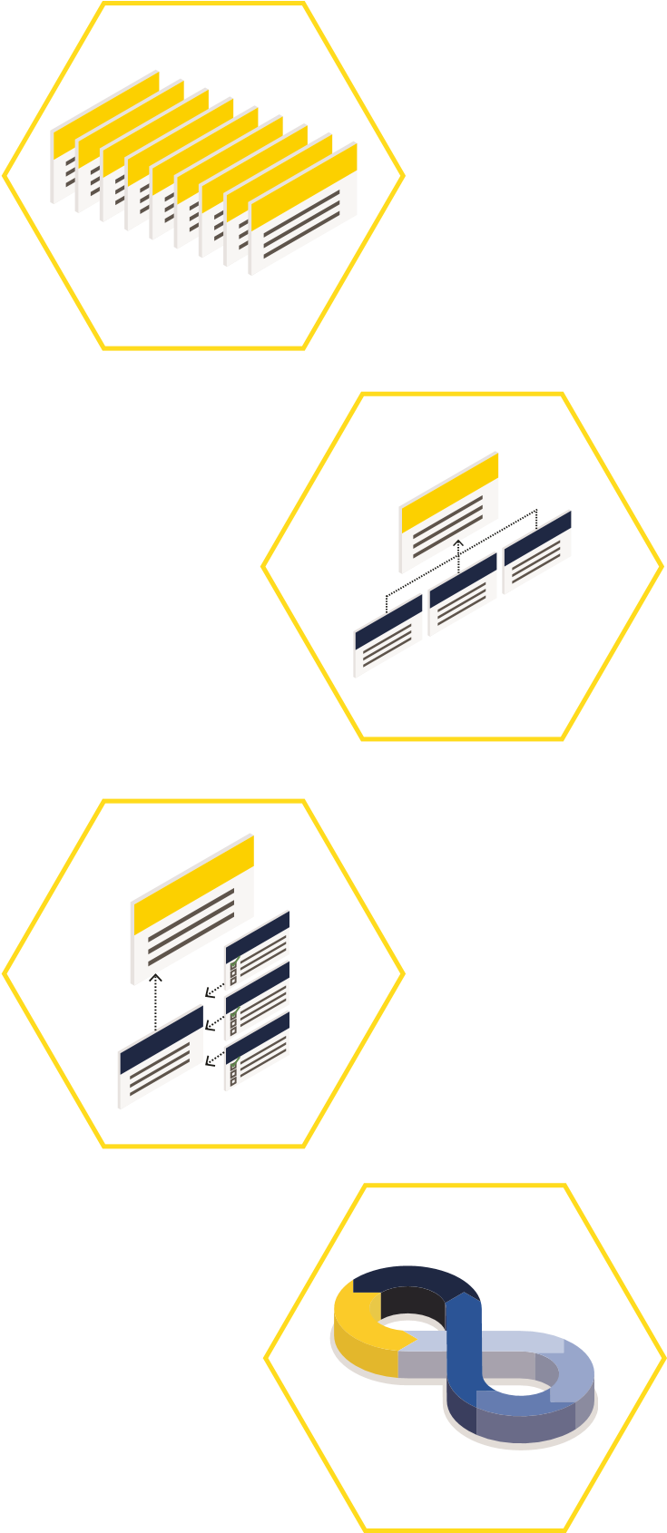
Business outcomes are the results needed by organizations to succeed in the modern world. Organizations use these to customize their Agile transformation strategy by prioritizing business outcomes to suit their needs.
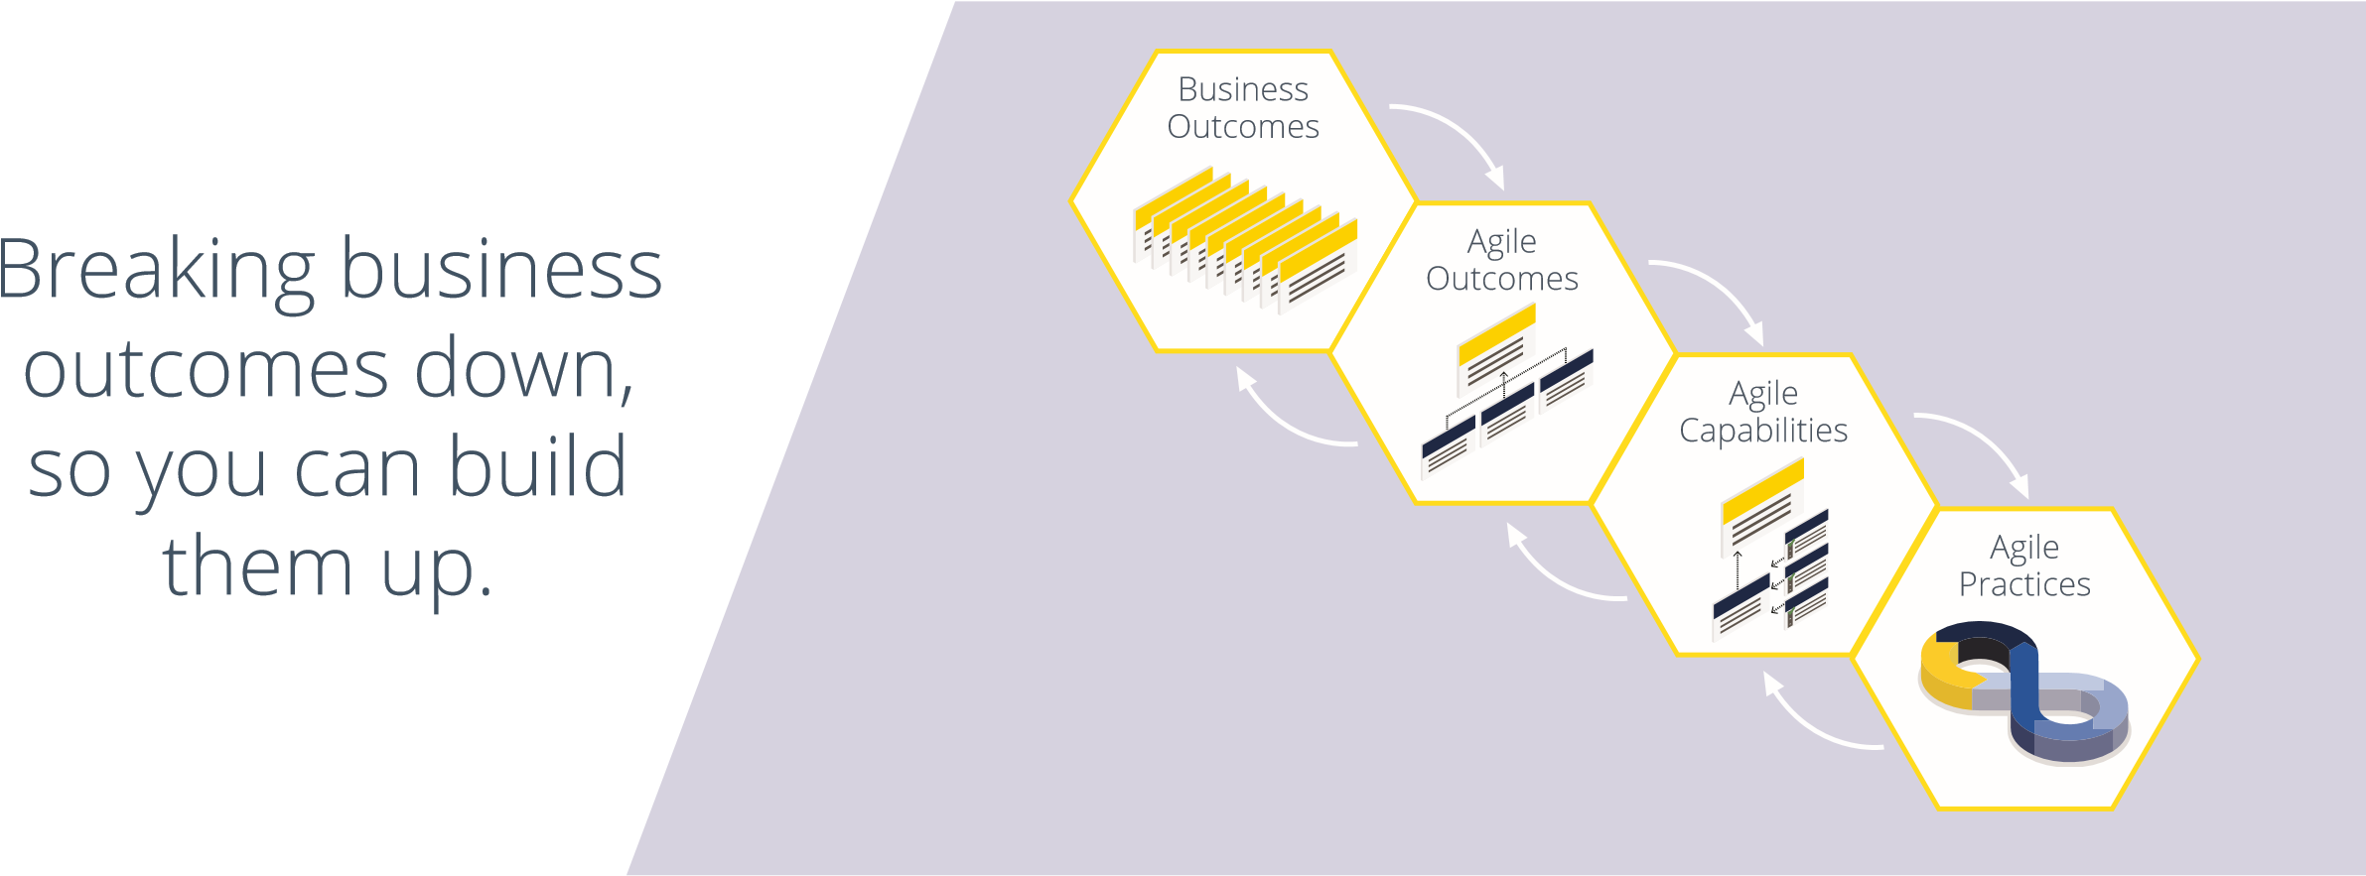
Agile outcomes are the organizational functions that come as a result of developing an agile mindset and fundamental Agile capabilities within the organization. When Agile outcomes are achieved, they then become the building blocks for achieving sustainable business outcomes.
Agile capabilities are the foundational behaviors and abilities that, once in place, will lead to the development of Agile outcomes. These capabilities are tangible and measurable, but may vary across an organization.
Agile practices are the processes, techniques, roles, meetings, and systems that are recommended in popular Agile frameworks like Scrum, Kanban and Scaled Agile Framework. These practices are the tools and building blocks that allow organizations to build specific capabilities needed to achieve desired Agile and business outcomes.

